All Maccabi Aquatics families must be registered for the Customer Portal to access valuable account information and complete important tasks.
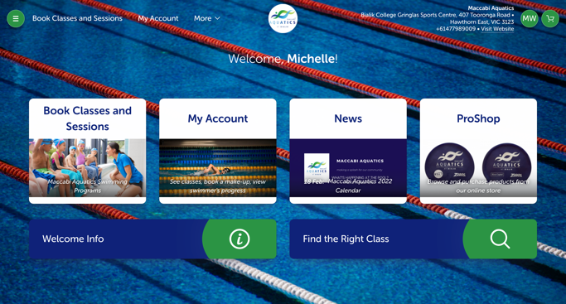
The Customer Portal allows you to:
> View swimmer’s enrolment details (class, day, time)
> View swimmer’s current and completed skill sets
> Update your account details
> Report absences
> Book make-up lessons
> View and pay invoices
Please note, all absences and make-up classes MUST be reported and booked via the Customer Portal, rather than with the Customer Support Team.

Make sure you also download the app version of the Customer Portal for access to your information wherever and whenever.

Logging in
All customers are registered automatically.
Your email address is your login and your password can be set by pressing forgot password.
As well as logging in through the website, you can download the app version of Customer Portal for access to your information wherever and whenever.
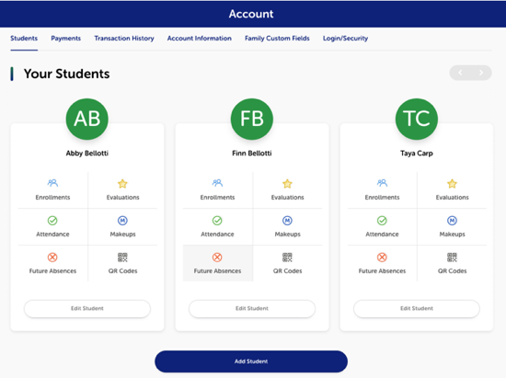
Account Information
Go to My Account at the top of the screen on by clicking the icon on the homepage. Here you can:
- see your classes,
- Record future absences,
- book a makeup class,
- view your swimmers progress,
- update your details,

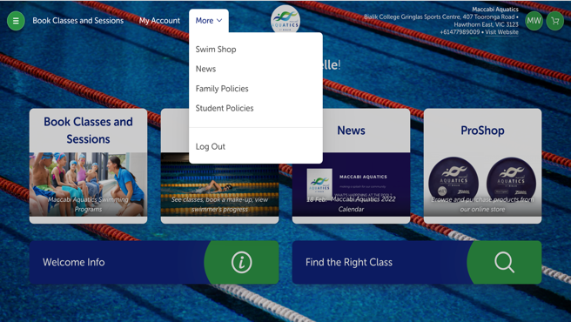
Viewing our policies
To view our student or family policies, hover or click on ‘more’ at the top of our homepage and select which policy you would like to view.

Purchasing merchandise
To purchase any merchandise,
Hover or click on ‘more’ at the top of our homepage and select ‘Swim shop’.
Select whichever product(s) you would like to purchase and follow the prompt to check out.
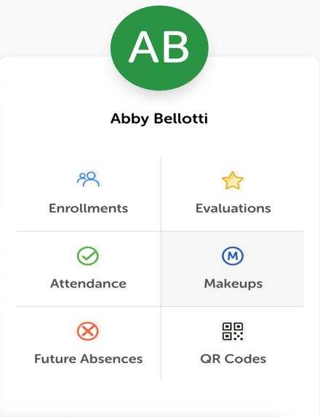
Notifying Absences
To be eligible for a make-up lesson you need to notify us of your child’s absence more than 5 hours before a group class or 24 hours prior to a private class.
Go to Account
Find the child(ren) who will be absent
Select future absences
Follow the prompt to record the dates of your child(ren)’s absence.
Your absence has now been recorded.

Booking Make-Up Lessons
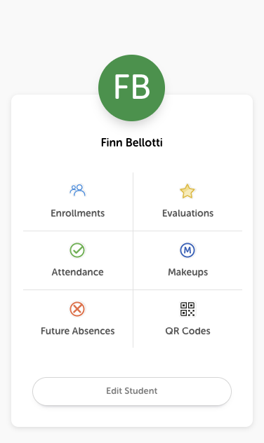
If you are eligible for a make-up class, simply book it through the Customer Portal.
Go to Account
Find the relevant child(ren).
Click ‘Makeups’.
Click ‘Available make-up tokens.
(If there is no available makeup tokens, this may be because we haven’t approved it, in which case it will be under pending me-up tokens, if you do not see it there and believe you should have a makeup token call our customer service team)
Select the ‘use makeup token’.
Select you desired date for the makeup
*Please note, makeups can only be booked 7 days in advance
Once you find a suitable class, select it
Your Make-up Lesson is now booked. will receive a confirmation email once it has been approved.

Make-Up Lesson Policy
If you are unfamiliar with our Make-Up Lesson Policy (what you are entitled to and when you are eligible etc.), It can be accessed and read via the Customer Portal or Maccabi Aquatics website and is written below for convenience:
Missed lessons can be ‘made up’ under the following conditions:
- Make-up lessons are limited to 1 per swimmer per month.
- Make-up lessons are not transferable to other siblings within the same family account.
- Once a swimmer ends their enrolment with us, all remaining make-up lessons expire.
- Notification of absence must be received a minimum of 5 hours prior to the lesson commencement.
- Notification of absence and all make-up lessons must be booked in via the Customer Portal.
- Make-up lessons are not guaranteed, and options may be restricted due to availability. This can include but is not limited to days, times and teachers.
- Make-up lessons expire at the end of the current term.
- No make-up lessons can be booked if you have outstanding fees.
- Make-up lessons cannot be cancelled or changed once booked.
- Make-up classes cannot be used as credits.
- Lessons missed during a holiday program are not eligible for make-up lessons.
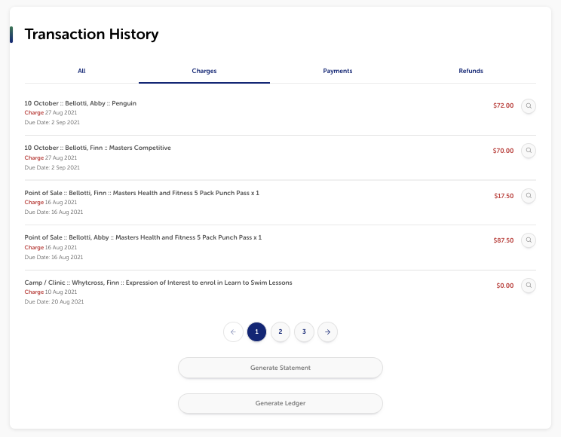

Viewing your transaction history Invoices
To view your payments or charges go to
Account
Transaction history
All charges (Unpaid and Paid), payments and refunds will be displayed.
At the bottom of the screen there is also bottom to generate a statement or ledger if you would like to.

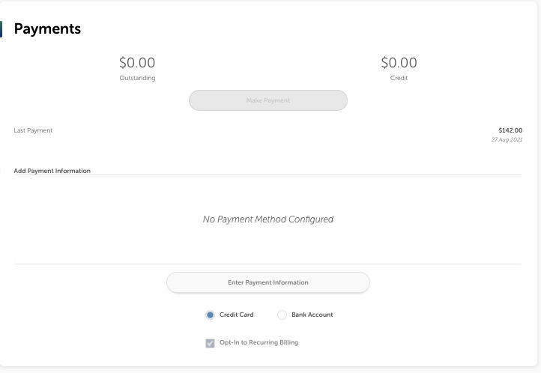

Viewing your Payments
To view your payments or charges go to
Account
Transaction history
All payments (Outstanding and Credits) will be displayed.

To pay your invoice
You will be direct debited automatically on the 1st of every month.
If you wish to pay yourself before the 1st of the month.
Go into the transactions tab
press Pay Now

